Case 9- MEX-Michoacan-Male-Leather Cap- Ear Spools-Terra cotta-100 BCE

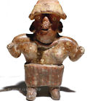

MEX-Michoacan-Male-Leather Cap- Ear Spools-Terra cotta-100 BCE

Case No.: 9

**Formal Label:** MEX-Michoacan-Male-Leather Cap- Ear Spools-Terra cotta-100 BCE

**Accession Number:**

Display Description:

“Michoacán” is derived from the [Nahuatl](https://en.wikipedia.org/wiki/Nahuatl) “*michhuah”* ("fishermen") and -*cān* (place of) on Lake Chapala. In the pre-Hispanic period, there were waves of migration into the area, including the Pirinda, [Nahua](https://en.wikipedia.org/wiki/Nahua_peoples), Huetamo, Colima. There are sites of formal settlements from all Mesoamerican periods. Important sites include [El Opeño](https://en.wikipedia.org/wiki/El_Ope%C3%B1o) and those in [Curutarán](https://en.wikipedia.org/w/index.php?title=Curutar%C3%A1n&action=edit&redlink=1" \o "Curutarán (page does not exist)), [Tepalcatepec](https://en.wikipedia.org/wiki/Tepalcatepec" \o "Tepalcatepec), [Apatzingán](https://en.wikipedia.org/wiki/Apatzing%C3%A1n" \o "Apatzingán), [Zinapécuaro](https://en.wikipedia.org/w/index.php?title=Zinap%C3%A9cuaro&action=edit&redlink=1) and [Coalcomán](https://en.wikipedia.org/wiki/Coalcom%C3%A1n_de_V%C3%A1zquez_Pallares" \o "Coalcomán de Vázquez Pallares). The territory has been inhabited by the Nahua, [Otomi](https://en.wikipedia.org/wiki/Otomi_people), [Matlatzinca](https://en.wikipedia.org/wiki/Matlatzinca_people), [Pirinda](https://en.wikipedia.org/w/index.php?title=Pirinda_people&action=edit&redlink=1" \o "Pirinda people (page does not exist)) and Teco peoples (UMSNH. 2011).

LC No.: F1219.A1

**Date or Time Horizon:** 500 BCE

**Geographical Area:** Mexico

Map:

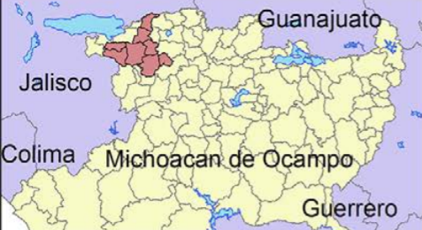

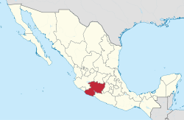



Figure . Location of archaeological sites (green, reported; yellow, registered) northwestern Michoacán bordering on Lake Chapala; map by David Muñiz.

**Cultural Affiliation:** Michoacan

**Medium:** Terracotta

**Dimensions:** 9 cm

**Weight:**

**Provenance:** Netherlands collection

Discussion:

References:

UMSNH. 2011. [*El Estado de Michoacán Epoca Prehispanica"*](https://web.archive.org/web/20100124211111/http:/www.umich.mx/mich/historia/prehisp.html) [The State of Michoacan, Pre-Hispanic Era]. Morelia, Michoacán: UMSNH.